GROUP ASSIGNMENT

**TECHNOLOGY PARK MALAYSIA**

**AICT005-4-1-DAS**

DATABASE SYSTEMS

UCDF2304ICT

HAND OUT DATE: 18th October 2023

HAND IN DATE: 17th November 2023

WEIGHTAGE: 50%

MODULE LECTURER: MUHAMMAH HUZAIFAH BIN ISMAIL

INSTRUCTION:

1. **Submit your assignment in the APU Moodle.**
2. **Students are advised to underpin their answers with the use of references (cited using the APA System of Referencing).**
3. **Late submission will be awarded zero (0) unless Extenuating Circumstances (EC) are upheld.**
4. **Cases of plagiarism will be penalized.**

|  |  |
| --- | --- |
| **Student Name** | **TP Number** |
| Alice Lim Jia Chee | TP074521 |
| Bryan Wong Junyi | TP074948 |
| Natalie Chew Jing Ling | TP073085 |
| Ng Jun Yuan | TP067314 |

**Table of Contents**

**a) Database and Database Management System**

**Disadvantages of a file-based system ………………………………… 3**

**Advantages of a Database and DBMS ……………………………….. 3**

**Functions of a DBMS …………………………………………………. 4**

**b) Business Rules & Normalization**

**Business rules ………………………………..………………………… 5**

**Normalization …………………………………………………………. 7**

**c) Entity Relationship Diagram …………………………………... 9**

**References ………………………………………………………… 10**

**a) Database and Database Management System**

**Disadvantages of a file-based system**

In the context of the case study for APU's eBookstore, using a file-based system to manage the database would come with several disadvantages. First, data redundancy is a significant concern, as each application typically manages its data in separate files, leading to duplicated data (Gillis & Posey, 2021). For example, customer information, order details, and book records would be stored in different files, resulting in redundancy and potentially inconsistent information. These redundancies can lead to operational errors and increased storage requirements (Gillis & Posey, 2021). Additionally, data isolation occurs when data is isolated within individual applications, retrieving information about members and their orders would be challenging. This will hinder effective data analysis and reporting. Furthermore, in a file-based system, data integrity is the responsibility of individual applications, increasing the risk of data errors and inconsistencies (Norton, 1996). Finally, the limited data security measures in a file-based system could pose a challenge when protecting sensitive customer and payment data without a centralized security framework (Norton, 1996).

In contrast, a Database Management System (DBMS) would address these disadvantages effectively. A DBMS provides a structured and centralized database where data is stored efficiently, reducing redundancy, and ensuring data consistency and integrity (*Difference between File System and DBMS*, 2021). It allows for better data retrieval and analysis, simplifies data management, and provides more robust security features. For APU's eBookstore system, which involves managing book orders, customer information, and payment details, a DBMS would be the superior choice, ensuring data accuracy, security, and streamlined operations, ultimately enhancing the overall functionality and efficiency of the online bookstore (Gillis & Posey, 2021).

**Advantages of a Database and DBMS**

By creating an online eBookstore, Asia Pacific University (APU) is taking an important step towards addressing the issue of the restricted book availability on campus. Students will also be able to borrow eBook online instead of borrowing a physical book that is hard to maintain. A strong database and a Database Management System (DBMS) are necessary to run APU library efficiently. There are numerous advantages of utilizing a database and DBMS, along with its functions within the framework of APU’s eBookstore project. Data integrity and accuracy is one of the advantages of a database and DBMS as it enforces data integrity rules, which guarantees the accuracy and reliability of book information, pricing, and customer data.

By doing this, the overall quality of service by avoiding mistakes and inconsistencies in book listings and customer interactions can improve. Data redundancy reduced is another advantage, it is achieved by efficiently and systematically storing information. It is crucial for the eBookstore because it reduces the possibility of inconsistent data arising from multiple copies of the same information and saves storage space. Another advantage is the data backup and recovery, where it offers reliable backup and recovery procedures, guaranteeing that in the case of data loss, accidental deletion, or system failure, APU may restore data to a consistent point in time. Data security and business continuity depends on this (Castro, 2018). Furthermore, enhanced data security is crucial, particularly when handling customer confidential information and financial transactions. In order to secure customer data, preserve their privacy, and guarantee the confidentiality of their information, a database and DBMS provides features like user access controls and encryption to secure customer data (My Reading Room, n.d.).

**Functions of a DBMS**

There are many different functions of DBMS, one of its many functions includes data storage, where it keeps tracks of important data such as book details, author information, customer profiles, orders, and inventory. This function is essential for organising a large amount of eBookstore-related data. Moving on, data retrieval is another function of DBMS, which allows users to efficiently search for books using a variety of criteria such as its title, author, and genre The data retrieval function improves the user experience by giving quick access to book information. Continuing with data security, as protecting customer data is important, data security function is very important. It controls access and encryption to secure customer data to ensure only authorised individuals can access the data. In addition, a variety of transactions, including book purchases and order updates, will be handled by the eBookstore. In order to promote efficiency and customer satisfaction, transaction management is a function that ensure that these transactions are handled consistently and dependably. Lastly, Backup and recovery is another function of DBMS, where it minimises risk of data loss so in case of system failures or corruption, APU will be able to recover the database to a consistent state, preventing further risk of data loss (Pizzo, 2022).

**b) Business Rules & Normalisation**

**Business rules:**

1. Publishers frequently send lists of latest books to the APU’s E-Bookstore manager, and the APU’s E-Bookstore manager can compile a list of needed books and send orders to many publishers and those orders need to be recorded. After that, the APU’s E-Bookstore manager needs to record the details of the order and books that order have arrived at the bookstore.

* Publishers can send at least one latest book list to the e-bookstore manager, APU’s E-Bookstore manager can make at least one order book for book lists to many publishers. (many to many)

* A publisher can transport at least one book already ordered to APU’s E-Bookstore, APU’s E-Bookstore manager needs to record at least one book that ordered and which book arrived in APU’s E-Bookstore. (many to many)

2. Customers need to become a member of APU’s E-Bookstore to purchase books online and members can view the book, look at reviews and compare another book in the same category.

* APU’s E-Bookstore members can view one or many books in APU’s E-Bookstore, many books in APU’s E-Bookstore can viewed by one or many APU’s E-Bookstore members. (many to many)
* One member can have only one membership in APU’s E-Bookstore, each membership is exclusive to one member. (one to one)

3. Members of APU’s E-Bookstore can add their purchase book into APU’s E-Bookstore shopping cart and the shopping cart will show the summary of the selection and total cost to be paid. Once the payment is made the order is confirmed and APU’s E-Bookstore will send the books to the customers within 7 working days.

* Each book’s name in APU’s E-Bookstore has to be unique in the summary of the shopping cart, and the shopping cart may have more than one book name to show the selection summary. (one to many)

* The total cost for the shopping cart is added by another book price together if the shopping cart has more than one book, and the total cost to be paid amount has only one value. (one to many)
* Each shopping cart order can be made by only one member, and each shopping cart order may have a different time to collect the payment. (one to many)

4. APU’s E-Bookstore database system should manage information about books in the bookstore, members and books they have ordered as well as payment details and delivery status.

* APU’s E-Bookstore database system store many books information and members, meanwhile APU’s E-Bookstore database system store many members ordered with payment details and delivery status. (many to many)

5. Members can also provide 'rating' for a book, as a score along with optional short text comment and the score and comment is not allowed to change after making a 'rating'; only one feedback per user to per book is allowed.

* A member can only have one feedback to that book which the member bought the book from APU’s E-Bookstore. (one to one)
* The 'rating' for a book has only a score with comment to 'rating' for one book only, a member may feedback one or more book as the members bought. (one to many)

**Normalization**

The UNF is consist of APU’s E-Bookstore shopping cart table are:

**UNF**

Order(MemberID, MemberName, MemberAddress, OrderID, OrderDate, BookNane, BookID, UnitPrice, Quantity, Amount, TotalAmount, PaymentID, PaymnentDate, RecivedDate, SendDate)

**1NF**

Step 1: Eliminate the Repeating Groups

Step 2: Identify Primary Keys

* MemberID
* OrderID
* BookID
* PaymentID

Step 3: Identify the dependencies

- Partial dependencies are:

* MemberID > MemberName, MemberAddress
* OrderID> OrderDate, BookID, Quantity, Amount, TotalAmount, PaymentID
* BookID > BookName, UnitPrice
* PaymentID> PaymnentDate, RecivedDate, SendDate, OrderID

- Transitive dependencies

* OrderID > ItemID>TotalAmount>PaymentID

**2NF**

Step 1: It must be in 1NF

Step 2: Remove Partial Dependencies

Existing Table:

- Member(MemberID, MemberName, MemberAddress)

- Order(OrderID, OrderDate, Quantity, Amount, TotalAmount, BookID, PaymentID)

- Book(BookID, BookName, UnitPrice)

- Payment(PaymentID, PaymnentDate, RecivedDate, SendDate, OrderID)

**3NF**

Step 1: It must be in 2NF

Step 2: Remove Transitive Dependencies

Existing Table:

- Member(MemberID, MemberName, MemberAddress)

- Order(OrderID, OrderDate, Quantity, Amount, TotalAmount, BookID, PaymentID)

- Book(BookID, BookName, UnitPrice)

- Payment(PaymentID, PaymnentDate, RecivedDate, SendDate, OrderID)

- Transaction(OrderID, ItemID, TotalAmount,PaymentID)

**c) Entity Relationship Diagram**

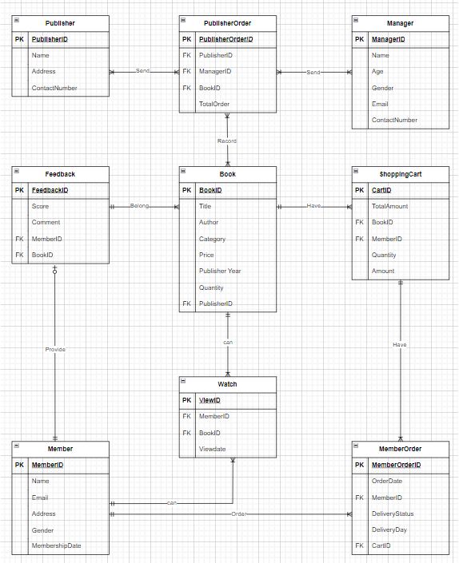

**REFERENCES**

Castro, K. (2018). Advantages of Database Management System. Tutorialspoint.com. <https://www.tutorialspoint.com/Advantages-of-Database-Management-System>

*Difference between File System and DBMS - javatpoint*. (2021). Www.javatpoint.com. <https://www.javatpoint.com/dbms-vs-files-system>

‌Gillis, A. S., & Posey, B. (2021). *redundant*. Storage; TechTarget. <https://www.techtarget.com/searchstorage/definition/redundant>

My Reading Room. (n.d.). What is DBMS? Advantages and Disadvantages of Database Management System (DBMS). Www.myreadingroom.co.in. <https://www.myreadingroom.co.in/notes-and-studymaterial/65-dbms/462-advantages-and-disadvantages-of-dbms.html>

Norton, K. (1996, September). *File-Based Data Management System*. Webopedia. <https://www.webopedia.com/definitions/file-management-system/#:~:text=A%20file%2Dbased%20data%20management%20system%20(also%20called%20a%20file,hard%20disk%20or%20flash%20drive>

Pizzo, M. (2022, February 17). 6 Benefits of Using Database Management Systems (DBMS) Pipeline Blog. <https://pipeline.zoominfo.com/operations/6-benefits-of-using-database-management-systems-dbms>